How to connect to your projector wirelessly:
**You will need to open the excel document sent to you to enter in your IP Address**
Turn on your projector and press the LAN button on the remote
1. You will need to find the “Easy MP Network Projector” Application on your start menu
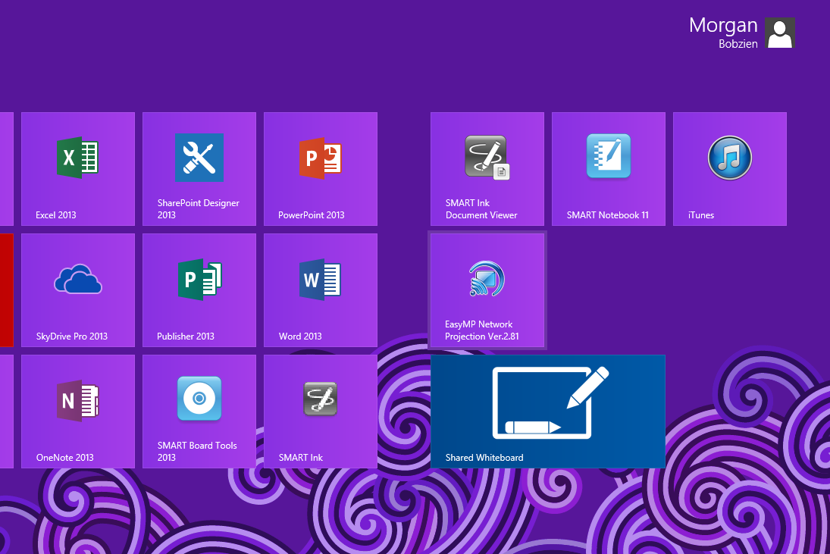
2. Click on the ‘Advanced Connection Mode’ and also check the box, ‘Set the selected Connection Mode as the default mode for future connections,’ then click, ‘OK.’

3. Click ‘OK’ to the Error Message
4. You will need to then do a “Manual Search” for your projector.
5. Enter in your IP address and press ‘OK’ (On the excel spreadsheet)
6. Click ‘Save in the profile’ tab. (This will save your IP address so you can click on ‘Profile at the top to connect next time.)
7. Click in the ‘Profile name’ box and type in your Room #, then click ‘Add.’ (You now should be able to click on the ‘Profile’ tab at the top and see your room #.)

8. Click and make sure your projector line is highlighted (navy blue) and click ‘Connect.’

9. You now should be connected
10. To change the screen back to your desktop computer, you will need to click on the ‘Projector Control’ button. Then click on ‘Switch PC Source,’ to switch back to a different source. The wireless projection is the ‘LAN’ connection.

11. To disconnect, click on ‘Disconnect’ or turn off your projector

Next time when you open ‘Easy MP Network Projector,’ you can click ‘Profile’ and your room number should be listed. If you go to another person’s room you will need to add their projector the same way as above.

